# **Geometric System Plotter v6 Quick-Start** Start-up

1. 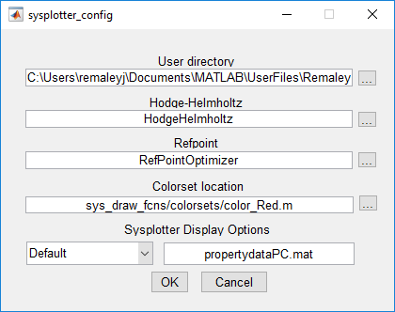Set the MATLAB working directory to …/GeometricSystemPlotter/ProgramFiles
2. Run sysplotter.m
3. The first time you run sysplotter, the sysplotter_config screen will appear.
4. Click “OK”. The options on this screen allow you to change the directory containing your system and gait files, the computational engines used by portions of the code, and the color set used to plot the system functions. You can later return to this screen, by running the function sysplotter_config.m).
5. Your screen should now display the sysplotter main window

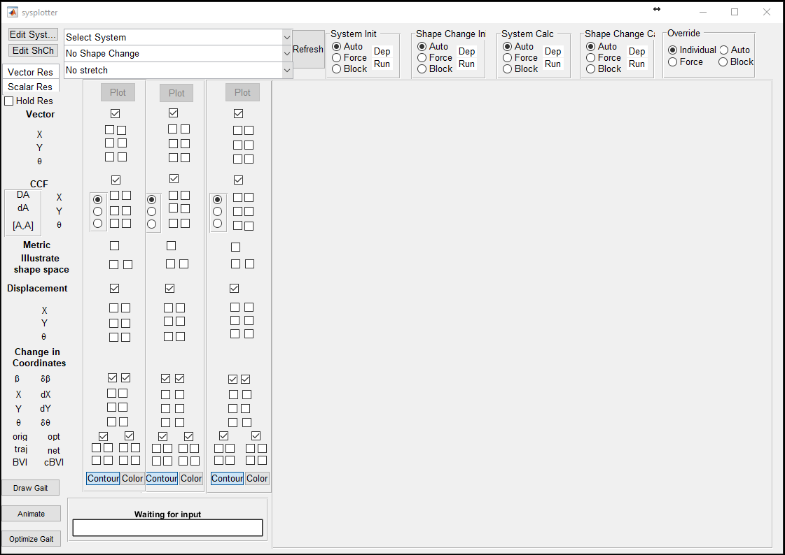

# Loading a System

1. Select the system you want to analyze from the “Select System” menu, e.g., the “3-link Viscous Swimmer”.

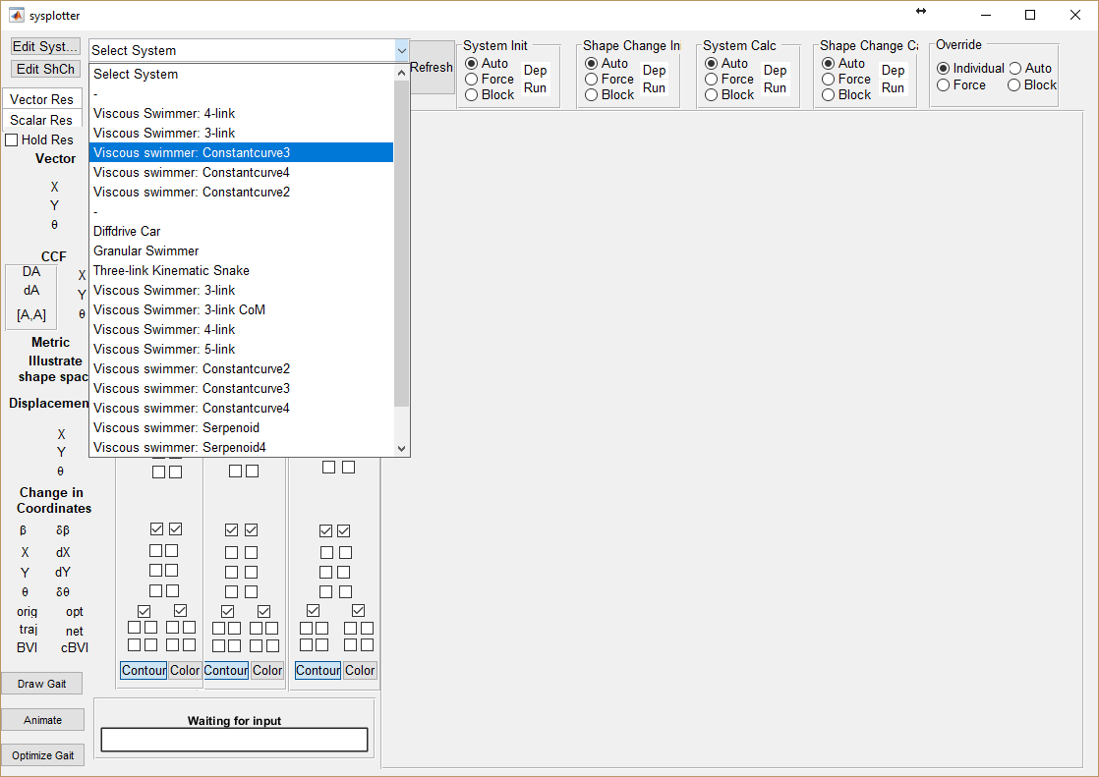

1. Next, select your “Shape Change”, we’ll use the “Circle Stroke, 1.0 amplitude”

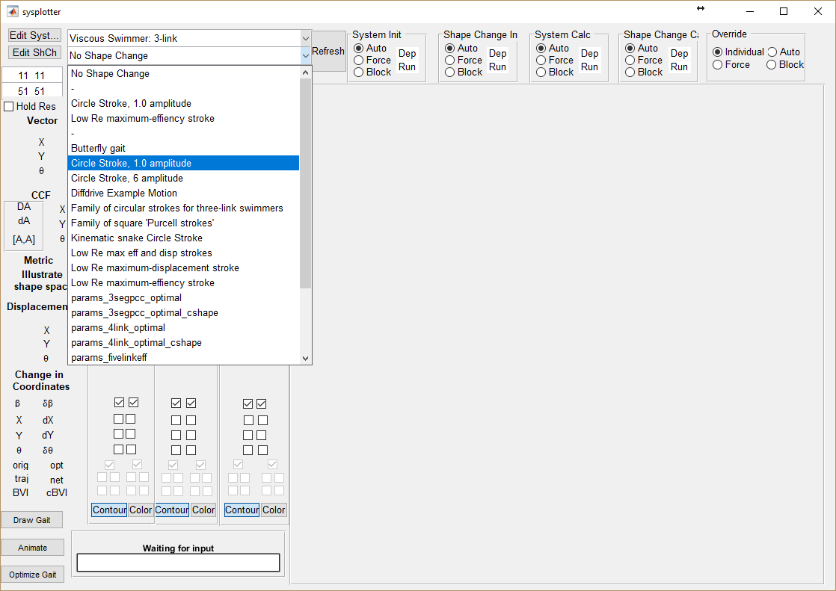

1. Ignore the “Stretch” menu for now
2. Now you’re ready to start plotting and analyzing.

# Plotting and Visualizing

Generate plots by selecting the corresponding checkboxes, then clicking the “plot” button. There are three sets of checkboxes (each with their own plot button), so that you can easily go back and forth between different sets of plots.

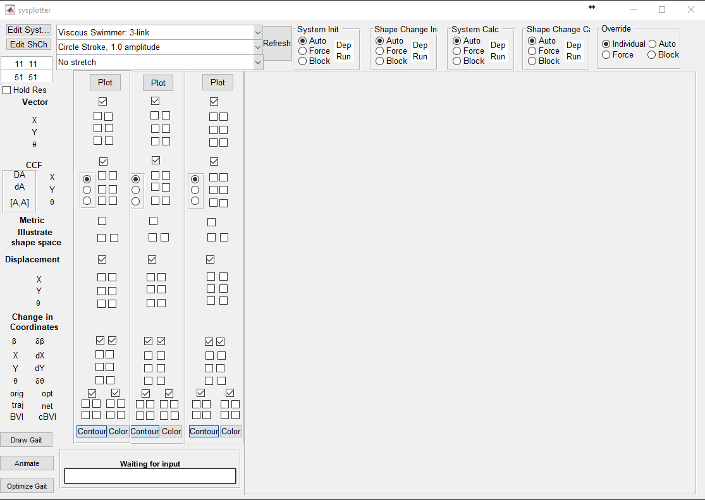

Each category of plots has a master-checkbox that toggles the whole block on and off.

The Vector, CCF, Illustrate shape space, and Displacement each have two columns; the left column plots the data exactly as it is specified in the system file, the right column plots it in the optimized (generalized/weighted center-of-mass) coordinate system. Each of the three rows in the Vector, CCF, and Displacement are respectively the x, y, and theta components of these quantities.

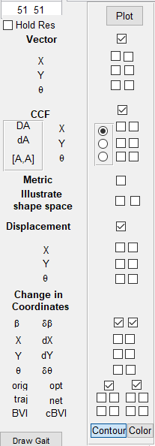

## Illustrate Shape Space

Selecting the illustrate shape space tick box gives us a plot of how the system looks at different points of the shapespace. Checking the left box plots the system in original coordinates and checking the right box plots the system in the optimized coordinate.

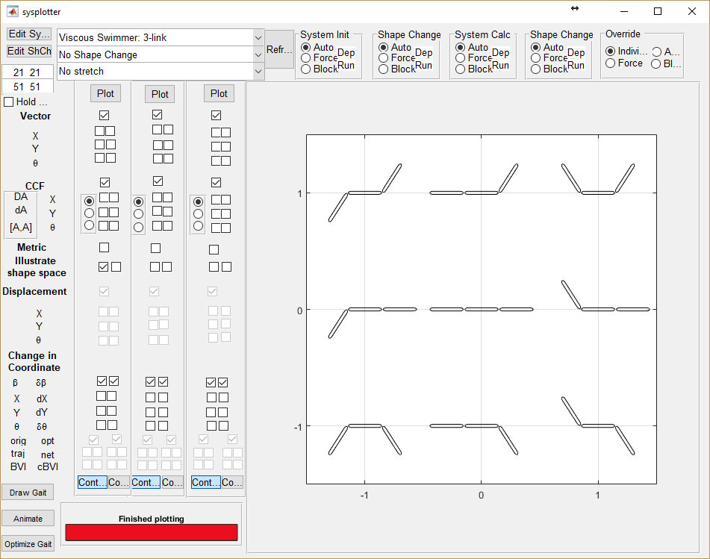

## Vector Fields

The “Vector” block plots the connection vector fields for the system, overlaid with the gait cycle selected. Here, all three fields are plotted in original coordinates

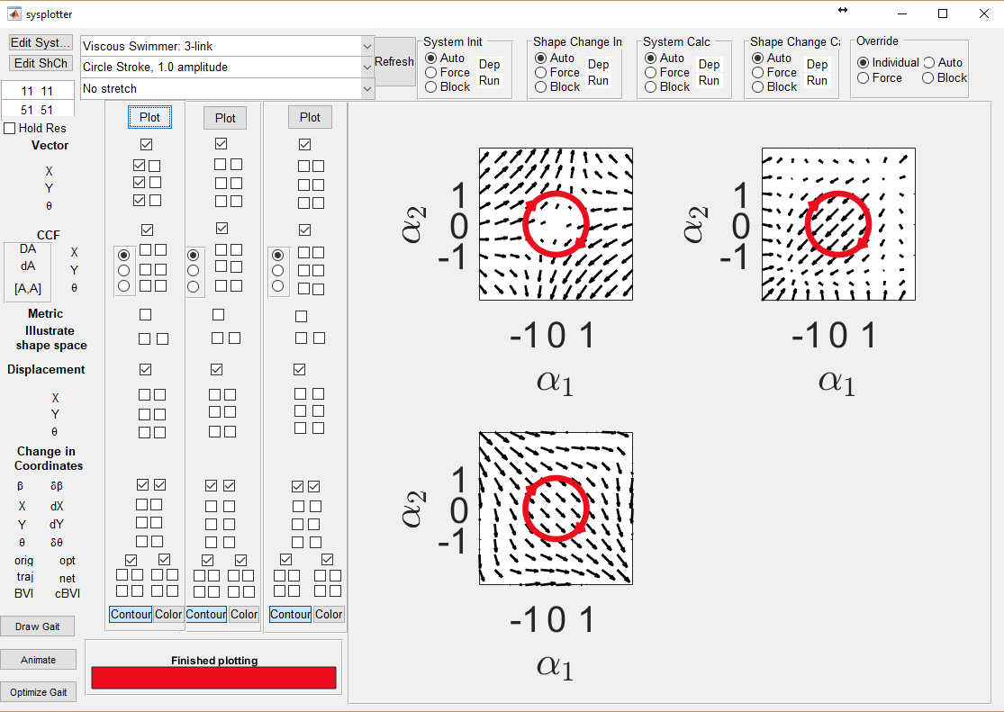

and here, the x component is plotted in original and optimized coordinates.

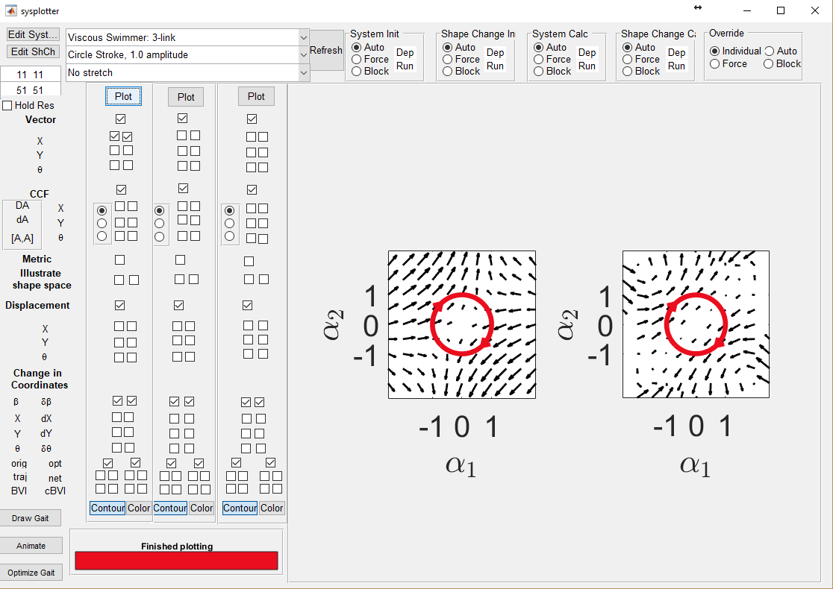

Constraint Curvature Functions

The constraint curvature functions work like the connection vector fields, except that there is a radio button for toggling between the constraint curvature functions giving DA (the total curvature, with both curl and Lie Bracket components), da (curl only) and the correcting factor [A,A] (the Lie bracket only). For system with three shape variables, the GUI plots the projection of the chosen constraint curvature function onto the plane most aligned with the function at the origin.

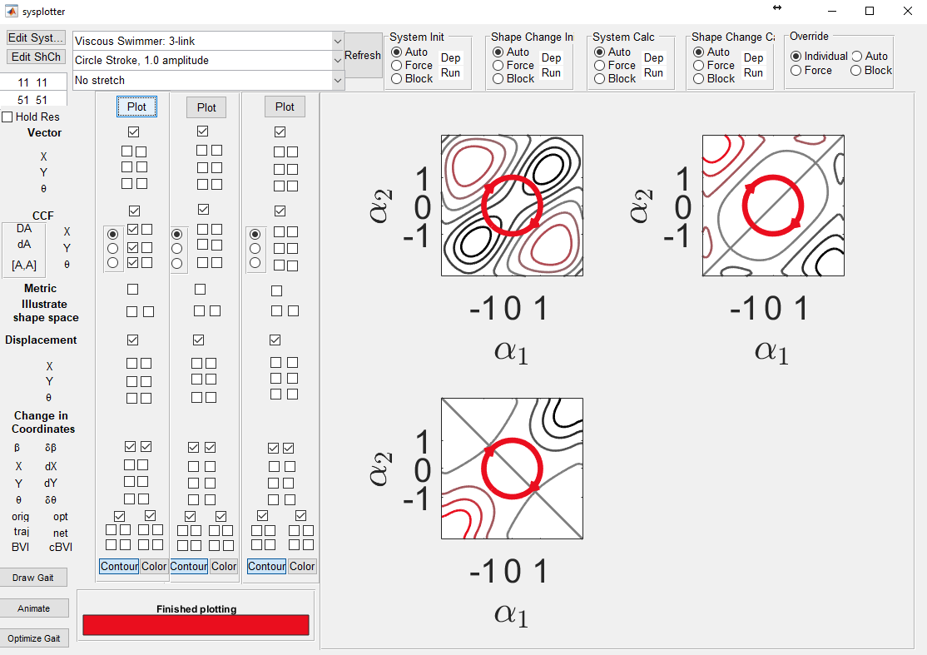

## Metric Field

Selecting the metric field checkbox plots a representation of the metric over the shape space. Here, circles of constant radius according to the metric are plotted as ellipses in the shape space (so that the short axis of the ellipse is the “long way” through the space. This block only has one checkbox, as the metric is defined for the overall system.

## 

## Displacement

Time history of the x, y, and theta components of the displacement.

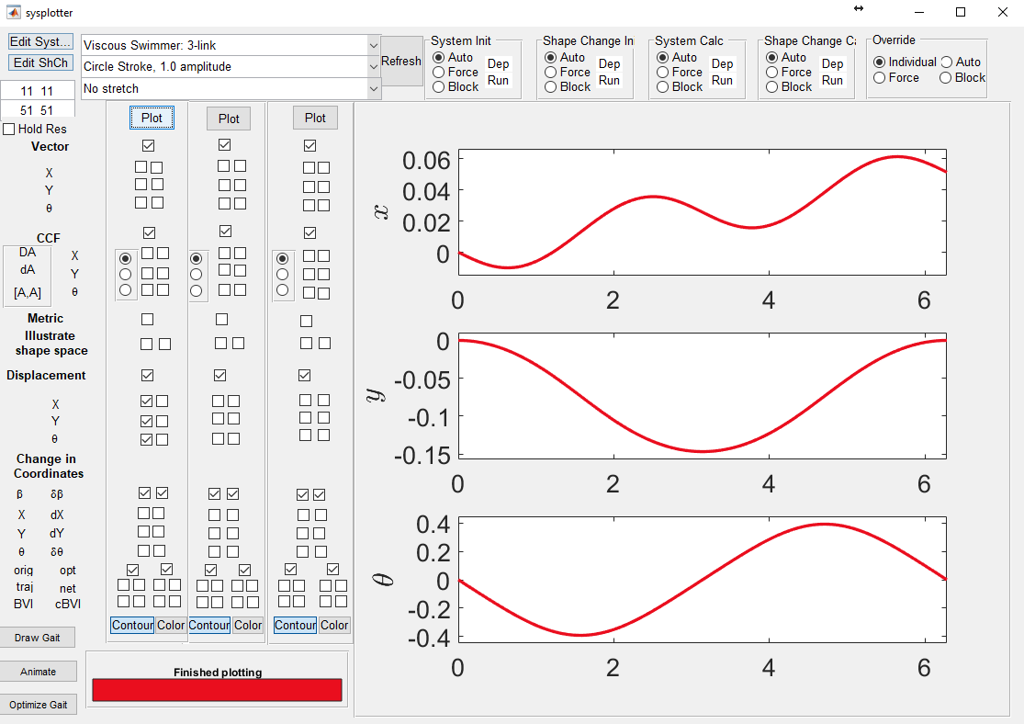

## Change in Coordinates

This shows the components of the transformation between original and optimal coordinates.

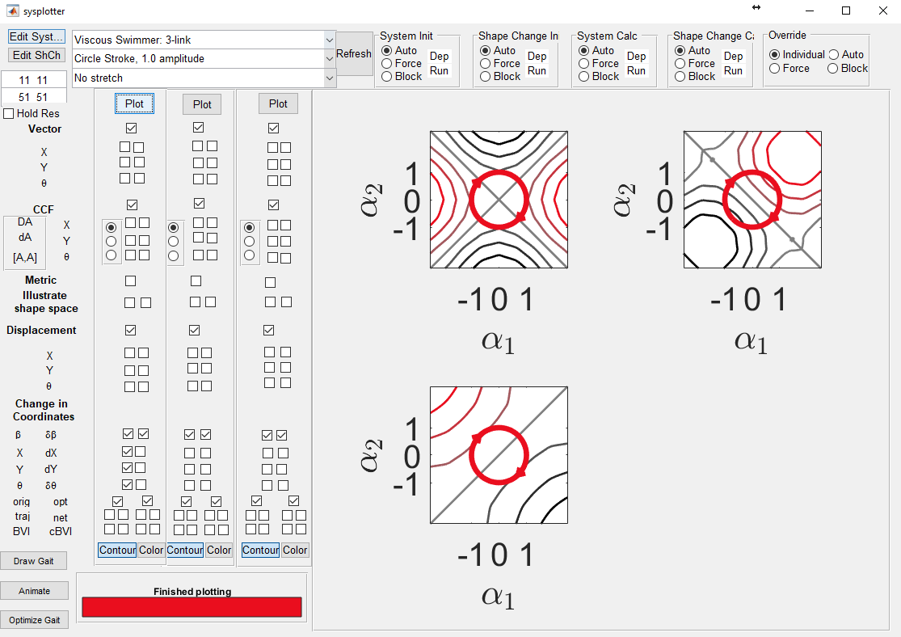

## Trajectories and Displacements

The bottom set of check operates somewhat differently from the rest. They are organized into two, 2x2 clusters. Each 2x2 cluster is organized as follows from top left to bottom right: trajectory of the body coordinate system, net displacement, body velocity integral estimate, and corrected body velocity integral estimate. The left cluster is in original coordinates, while the right cluster converts to optimized coordinates.

The image below shows the trajectory taken by the original coordinate frame, and the estimate the body velocity integral (BVI) and the corrected body velocity integral (cBVI) give for the displacement. Note that the error is greater for the original coordinates than for the optimized coordinates.

(In the optimal coordinates *for this particular gait*, the cBVI term actually has more error than the plain BVI, but this is because the coordinate optimization has reduced both errors, and third-order terms are now dominating the error).

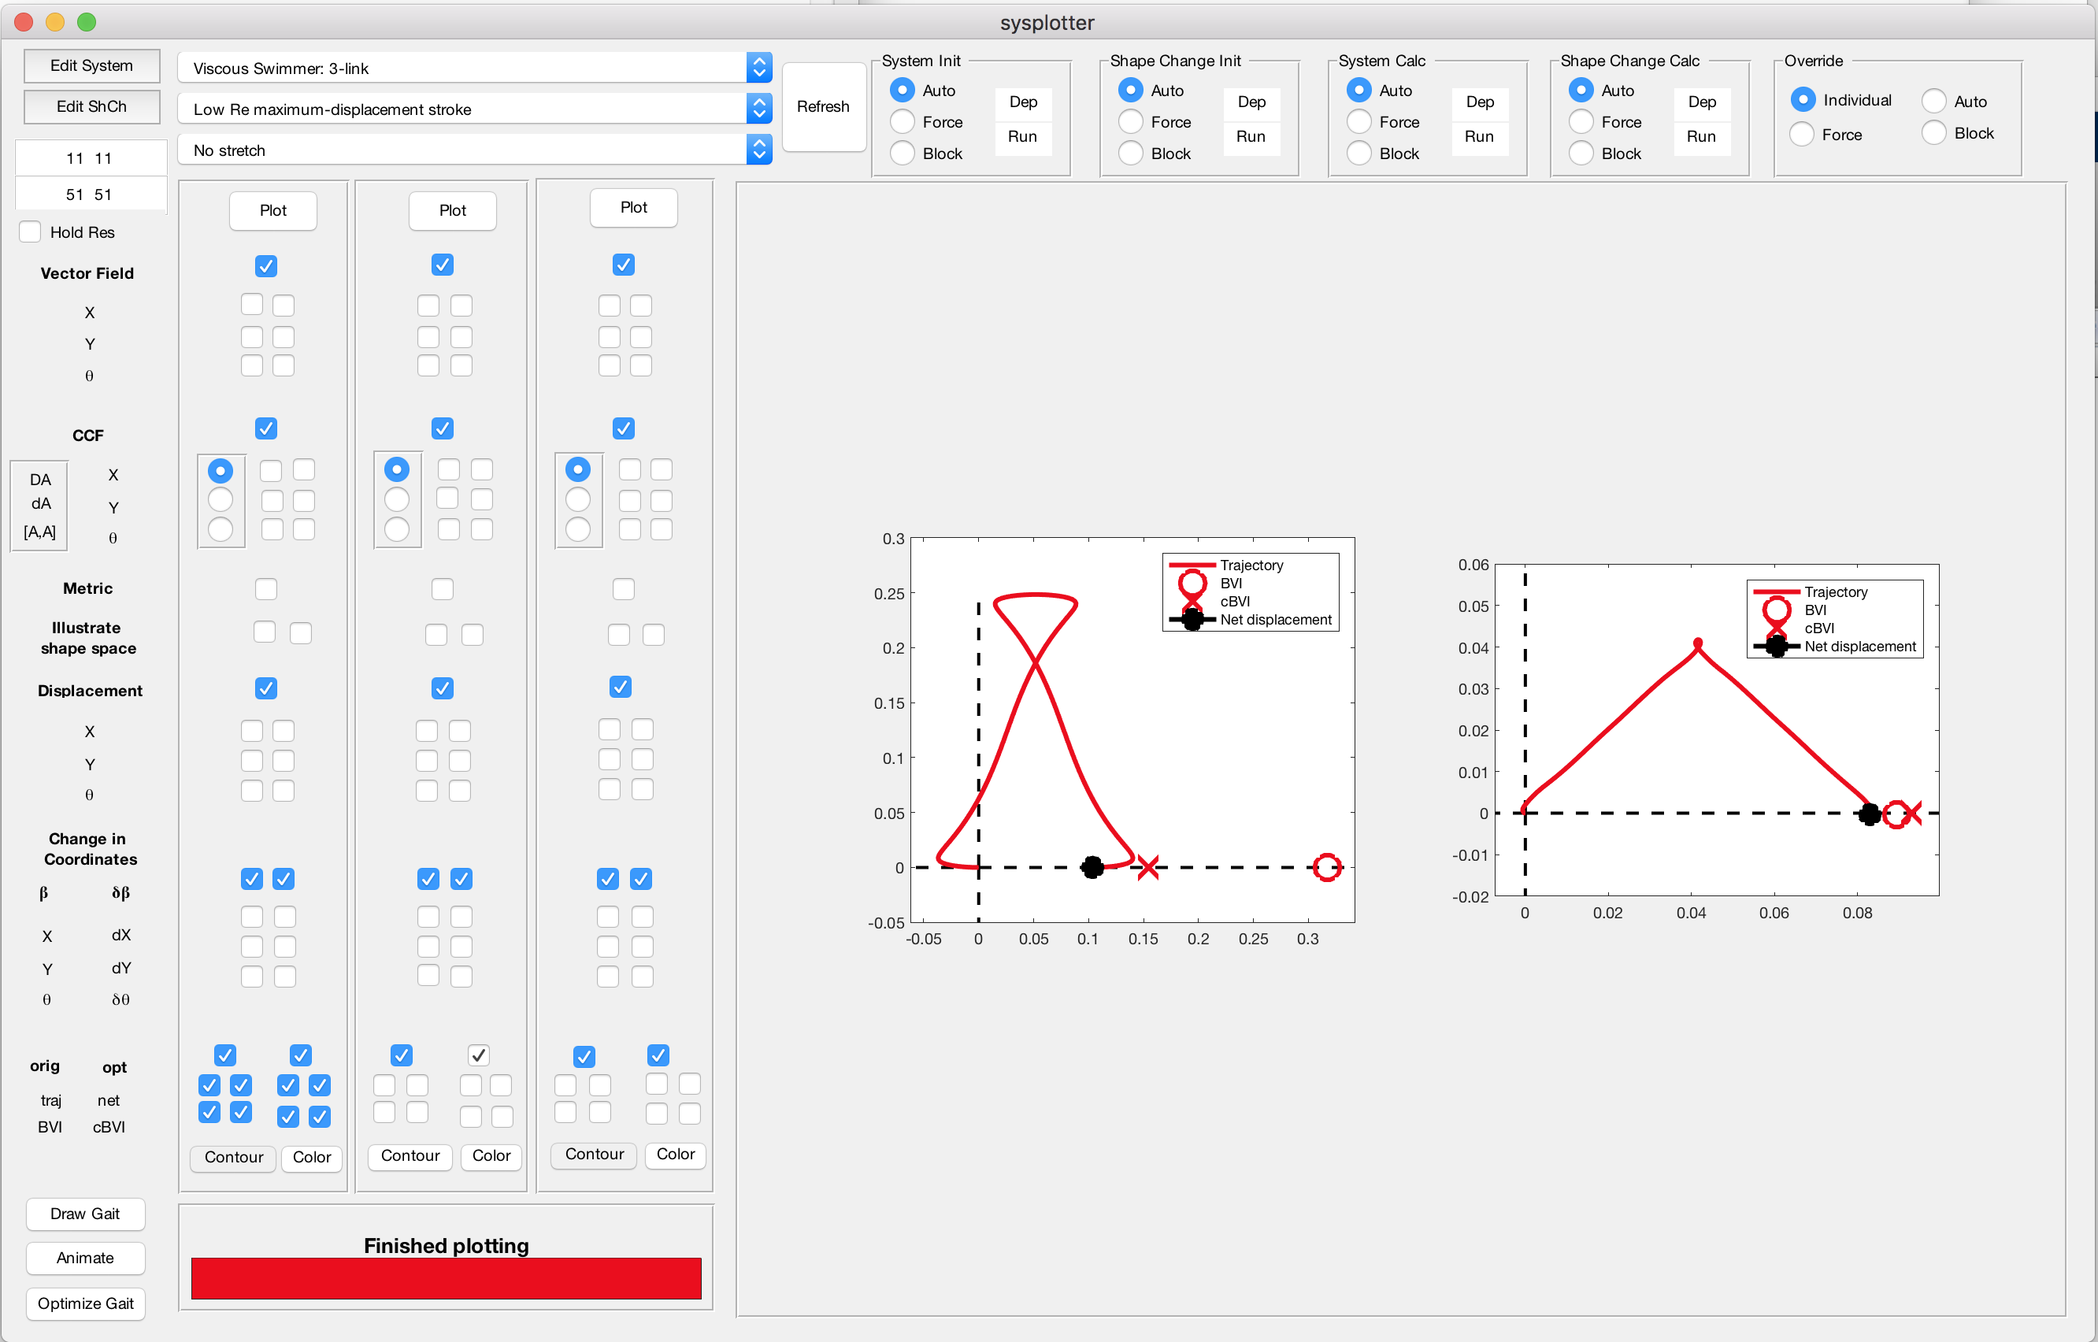

# Custom Closed-Gait Generation

1. Generate a constraint curvature function or a vectorfield.

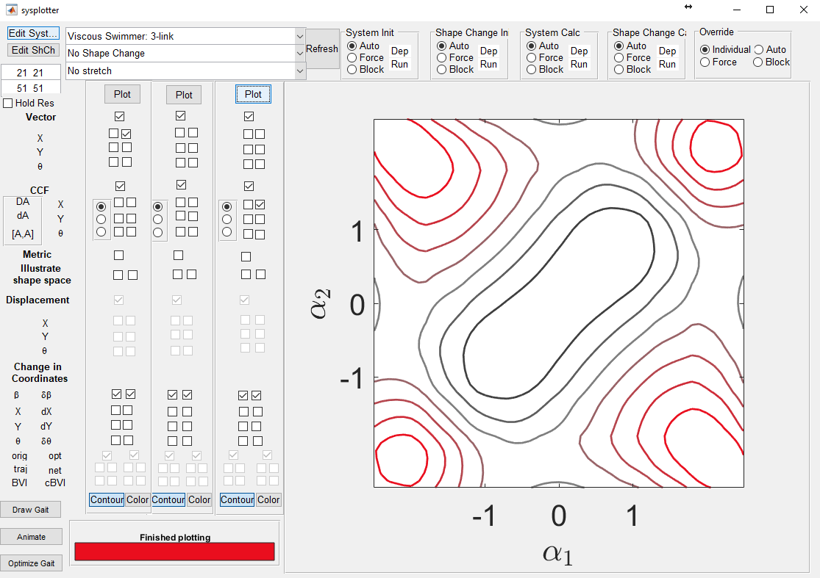

1. Select the “Draw Gait” button in the lower left of the GUI. 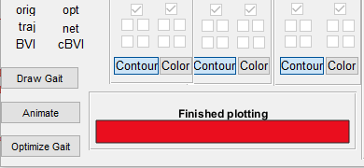
2. Click inside the figure of the height function to add points, hit enter when done, a save dialog will appear to save your gait contour in your userfiles folder. Before saving, you can preview the spline fit to your points in the same window used for entering them.

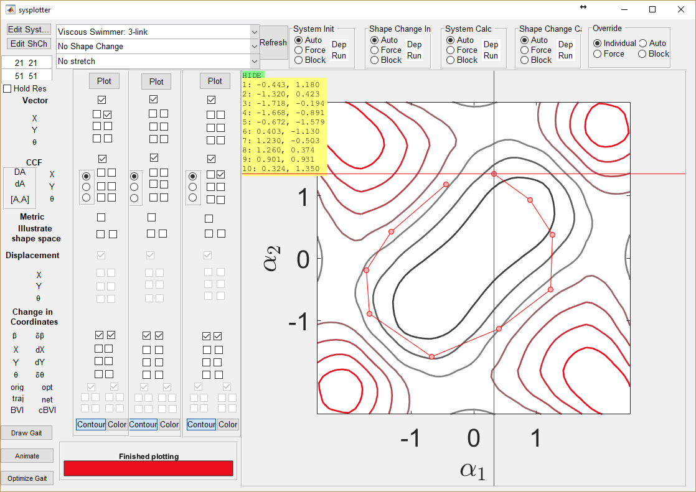

1. Now, in the sysplotter main gui, you can select your gait, through the Shape Change menu.

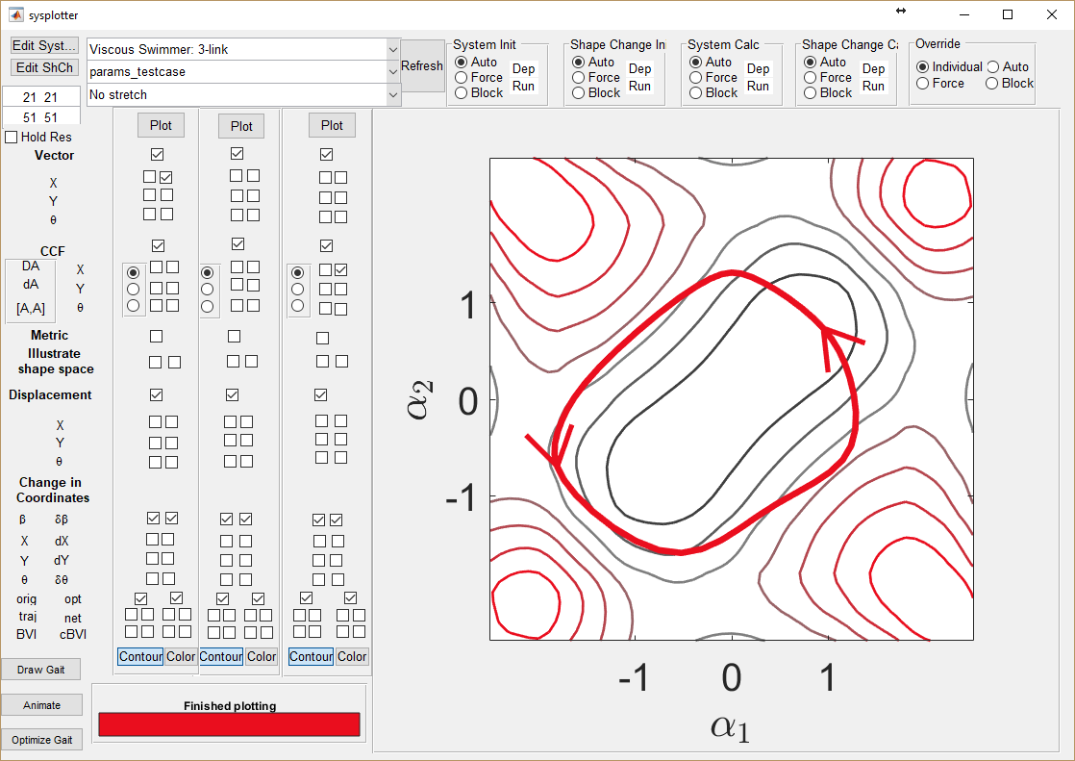

# Optimizing Gaits

The optimize gait button can be used to optimize a user-defined gait for the selected system.

With any gait plotted, select the optimize gait button located in the bottom left corner. This will use the existing gait as a seed for the optimizer, which will periodically display information in the command window until a solution has been reached. As an example, after running for roughly two minutes, this was the output of the display window:

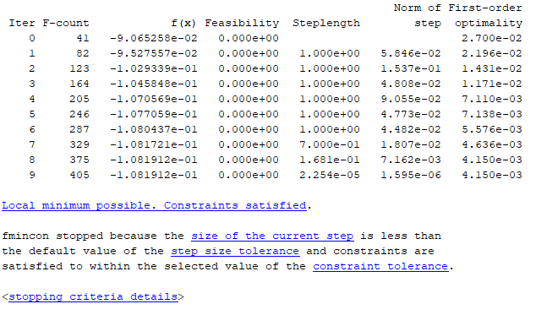  
  
While the optimization is in progress, on the GUI, the gait in black is how the gait looks at the current iteration of the optimizer, and the gait in grey is how the gait looked at the last iteration of the optimizer.

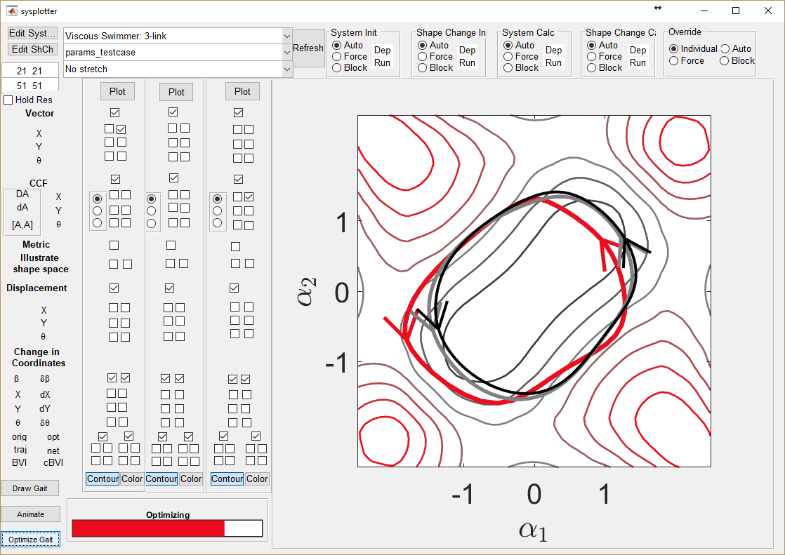

The optimized gait is automatically displayed in Sysplotter once optimization runs to completion.   
  
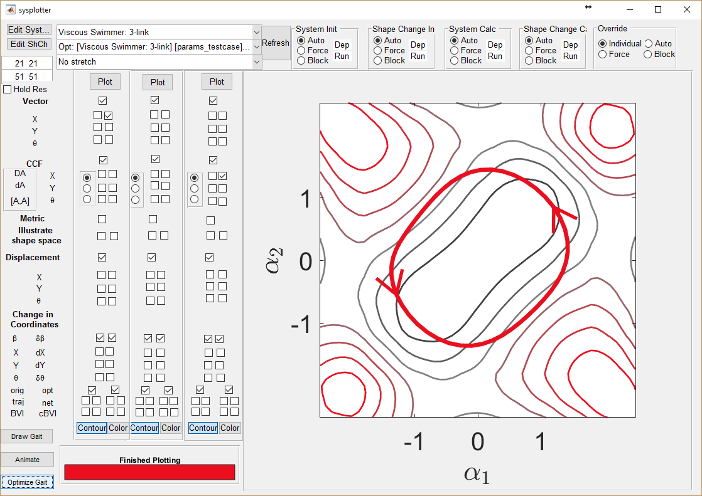

# Odds and Ends

Use this button to change the height function from contour to surface representations.

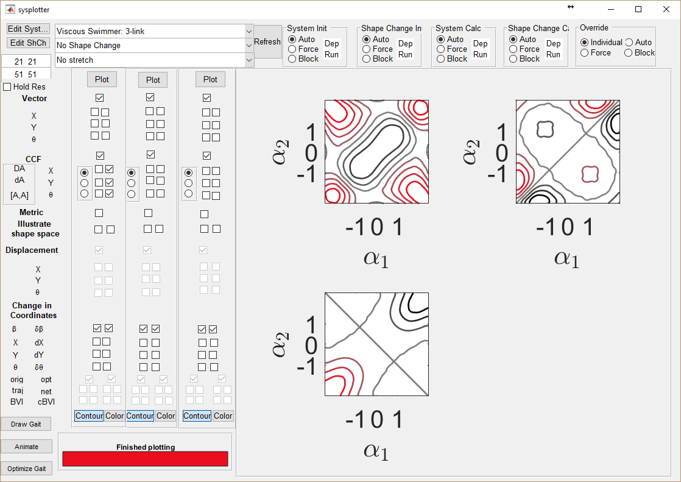

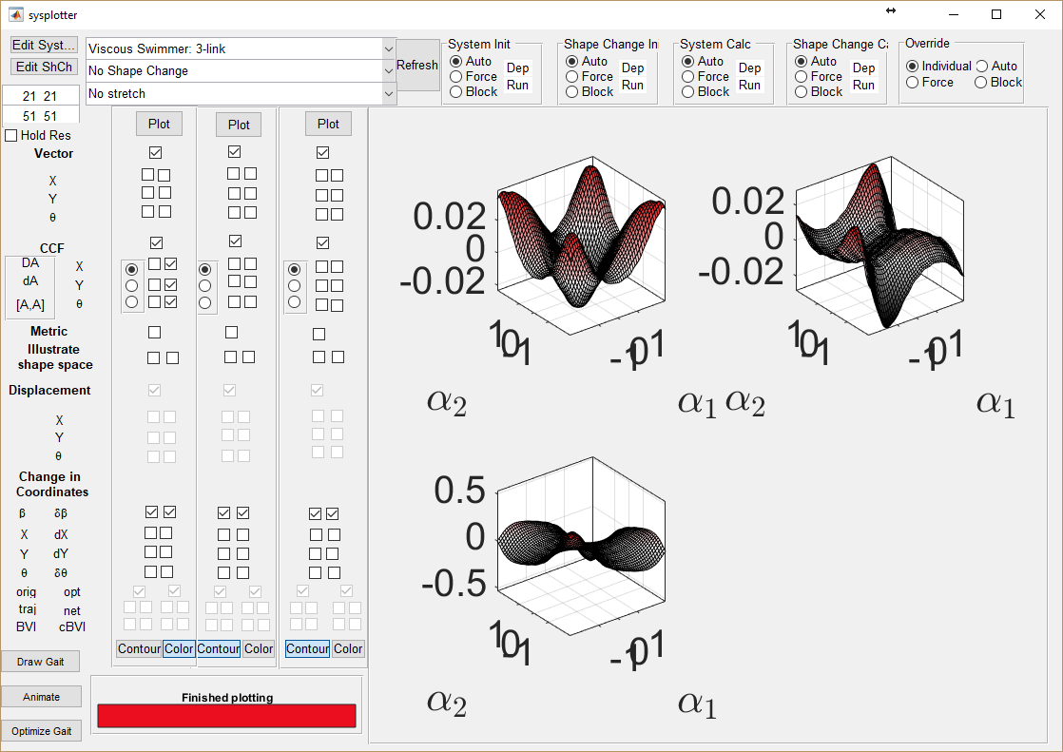

Also, all plots can be clicked on to produce a single figure containing that graph. These figure windows have the plotted contents title as the window name, and do not close when Sysplotter is run again.

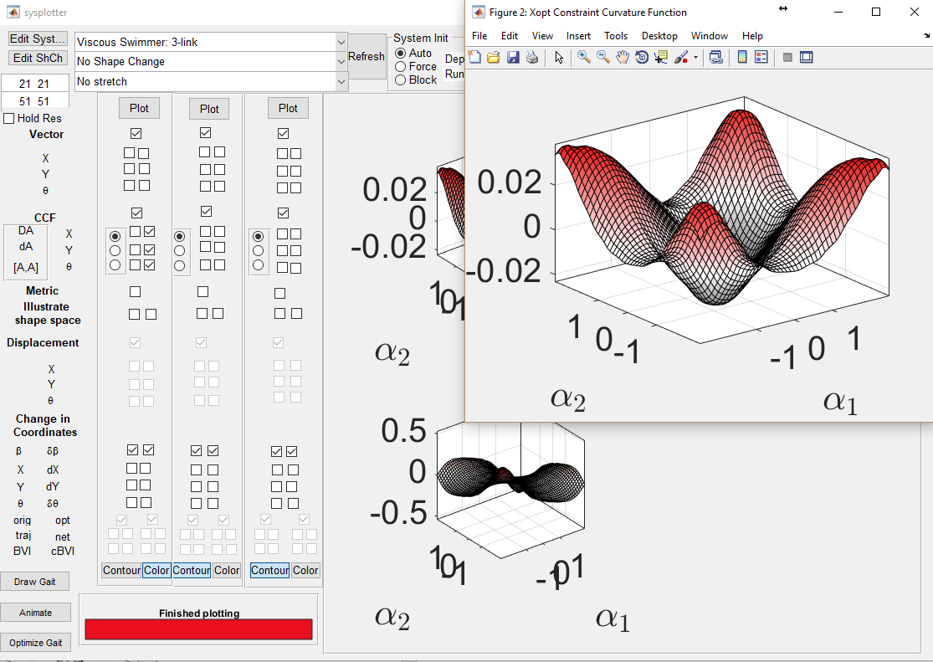

# Adding your own files

You can add new systems and shape changes to sysplotter by:

1. Clicking the “Edit” buttons to the left of the selection menus 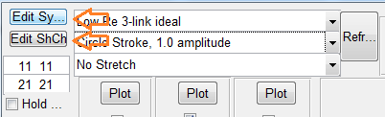
2. Saving a copy of the file into the appropriate directory. Make sure the file starts with sysf_ or shchf_ (system file or shape change file) so that sysplotter will recognize it. The figure below is a sample system file for the three-link (Purcell) swimmer followed by a sample gait file. We highlight some of the properties that can be easily changed.

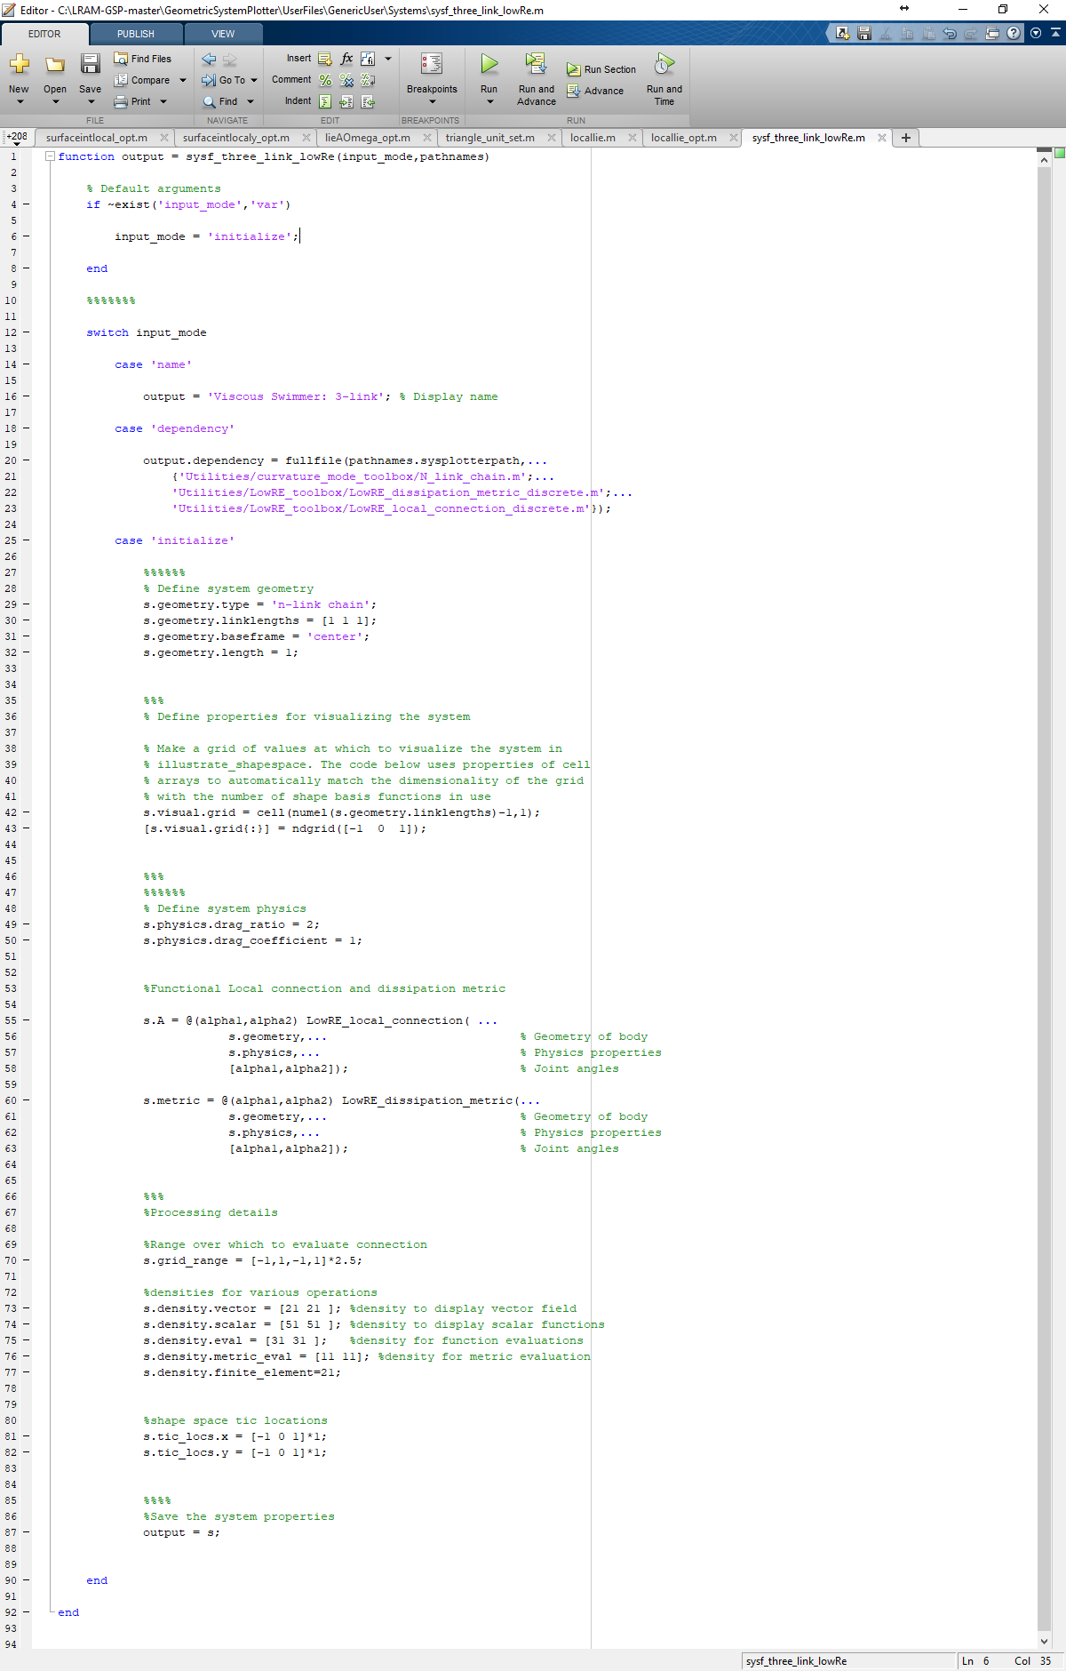

Ratio of the three links. [1 1 1] indicates the three links are equal in length.

Total length of swimmer.

s.geometry.type defines the geometry of the LowRe swimmer. You can choose between ‘n-link chain’ and ‘curvature basis’ based on if your swimmer is discrete or continuous.

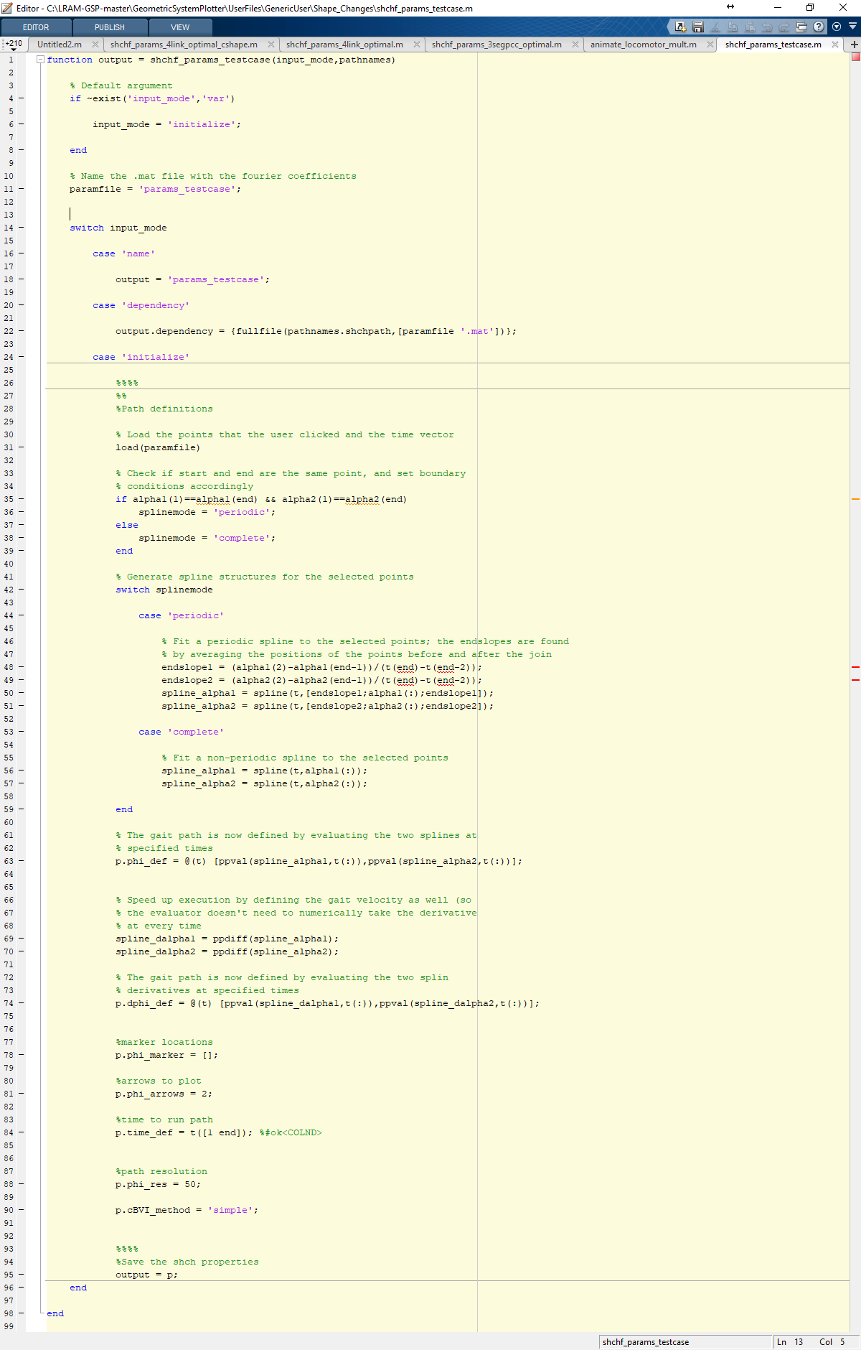

1. Changing lines of code in the file to get the behavior you want. Be sure to update the display name.
2. Click the Refresh button to the right of the selection menus to have the new file adopted into the menus.

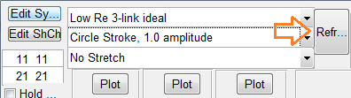

# Re-calculating System and Shape Change data

# The boxes on the top right of the interface contain radio buttons which can modify how Sysplotter calculates the selected data. By default, to save time, Sysplotter will check to see if any of the system or shape change files have been changed. If they have not, the most recent data will be called and no calculations will be performed. If they have, Sysplotter will run the new files to generate fresh data which will override the old.

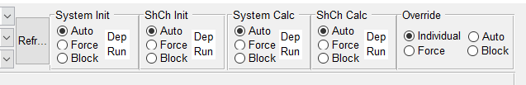

The refresh button causes Sysplotter to check the user directory for systems and shape changes for new files or changes to existing files.

Initialize and Calculation panels contain three options:

* Auto: by default, allows Sysplotter to automatically decide whether or not to run fresh calculations.
* Force: Sysplotter is required to run all calculations, regardless of existence of previous data.
* Block: Ignores changes in files, and uses only previously calculated data.

The override panel acts as a controller for the other panels. When set to individual, each of the other panels acts on its own and the settings can be changed individually. When set to Auto, Force, or Block, all of the other panels act the same according to the selection.